Techno Machine Tools
Survey no:126/A/1, DOOR NO: 4-132-9/A/2, Gandimaisamma X Road,
Medchal Malkajgeri,Hyderabad-500043.Telangana, India

T.SIVARAMAKRISHNA
ME., MBA.

TMT/MG PLASTICS UDYOG/S0175/2025 08-04-2025

To,
Mukul Kashyap
Company : MG PLASTICS UDYOG
Phone No :--+917395031003
Mobile No :+917395031003
Email : mgplasticudyog@gmail.com
City : Lucknow
State : 'Uttar Pradesh'

Dear Sir

SUB :- SUPPLY OF HORIZONTAL PET BOTTLE BAILING PRESS

With reference to our discussions regarding your requirement of Pet Bottle Bailing Press. We are glad to inform you that, we are in a position to supply you the required equipment. The following are the specifications and our terms and conditions.

Specifications of the equipment

GENERAL DATA

Productivity : BAILING OF PET BOTTLE

Manpower required : ONE OPERATOR ONE ASST. REQUIRED

Total Power Required : 5 HP

Set up time : LOADING 6-8 MIN, FEEDING 3-4 MIN

Production capacity : 2400 KG PER SHIFT 8 HOURS

Working hours per day : 24 HOURS

Overall floor space required : 2.6 METERS (L) 1.2 METERS (W) 1.6 METERS (H)

Approx weight : 2000 KG

Pressing Speed : 3-15 MPM

Model No : TM/RF/114

Model Type : CBBP

MATERIAL SPECIFICATIONS

Type of material to be processed : PET BOTTLE

Chamber of press : 800x800 MM

Bail size : 800x800x800 MM

Minimum thickness on bail : 800x800x200 MM

Maximum Weight of the bail
In pet bottle : 180 kg

❖ Max Working Pressure - 250 Kg/cm2
❖ Normal Working Pressure - 200 Kg/cm2
❖ Design Pressure - 250 Kg/Cm2
❖ Tonnage at 200 Kg/cm2 - 20 Tons
❖ Cyl Bore - 160 mm
❖ Rod Dia - 120 mm
❖ Stroke - 1200 mm
❖ Mtg - Front Flange
❖ Approach Speed - 60 mm/sec
❖ Pressing Speed - 0-5 mm/sec
❖ Return Speed - 120 mm/sec
❖ HP - 10.0 HP
❖ Tank Cap - 200 Ltr
Chamber size - 1100x1100 mm

Detail Bill of Material

❖ Cylinder Seals -Imported German Seals ( Merkel or Halite )
❖ Motor -ABB / Siemens / Kirloskar / Crompton
❖ Rod Seal - Imported halite Seal
❖ Valves -Yuken / Polyhydron / Hydrotech
❖ Check Valves -Polyhydron
❖ Hydraulic Pump - Yuken / Dowty
❖ High Pr Pump -Polyhydron
❖ Bell Housing -Micro
❖ Relief Valves -Polyhydron
❖ Hyd Tank - Micro
❖ Hyd Tank - MHPL
❖ Fitting -Hyloc / Hydair
❖ Gasket -Champion
❖ Fastners - TVS / LPS

S No | Description of the unit | Offer/unit
1. | Pet bottle bailer press with 15 hp drive and with double action cylinder is with the following specifications.  Drive : Electricity (5 HP with Starter)  - RPM : 1440 RPM  - Power : 5 HP  - Input : Single Box (Stationary type)  - Bale Size : 800 x800x800’  - Bale Weight : 160 to 180 KG (Basing on the material_  - Cylinder : Double acting high speed  - Oil : 68 grade hydraulic oil  - Operating : Single lever  - Load Control: Relief valve  - Power Consumption P: Idle 1.5 to loaded 2 units / hour | Rs 2,80,000/-  (Two Lakh Eighty Thousand Only)

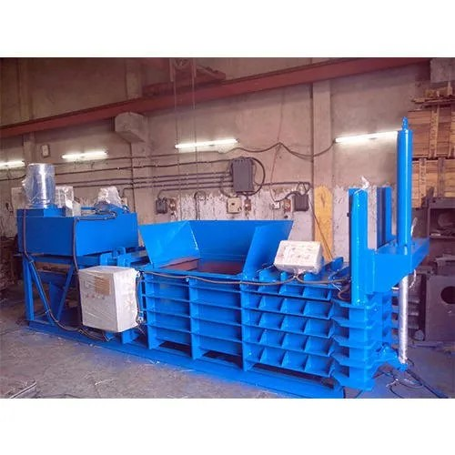
GENERAL TERMS & CONDITIONS:

1. Price quoted per unit ex-work. Hyderabad.
- Following charges are additional to your account.
- Freight Charge : As actual to be borne by you.
- Sales Tax : GST 18% Extra as applicable
- Packing charge : As actual to be borne by you.
- Insurance : As actual to be borne by you.
- Payment : 50% advance along with order balance before delivery but after inspection at our works.
- Delivery :With 50% advance 2/3 weeks from date of advance received
- Validity : One month from the date of submission.
- Inspection : Inspection at our works prior to dispatch.
- Warranty : The machine is warranted for a period of 12 months from the date of dispatch against any manufacturing defects/ faulty material or bad workmanship of any part or component but not against any kind of abnormal or improper use of machine. Defective part or component will be replaced or repaired free of cost. Electrical components are outside the scope of this warranty.
- Commissioning : Erection & commissioning done by you, but required technical support & guidance provide by us at additional cost.

NOTE:
- Oil is not in scope of our supply.
- Raw material for trial is to be arranged by you at your cost.

We are sure you will find our offer in line with your requirements. Should you require any further clarification please contact 9246221106

Thanking you and assuring you of our best services

For TECHNO MACHINE TOOLS

( T. SIVARAMAKRISHNA)

